|  |  |  |
| --- | --- | --- |
| *LSMA Beyond ~~-~~ Data Design* | *Red Text: Primary key* |  |
|  | *Blue Text: Foreign Key* |  |
|  |  |



Group 502~~-~~3

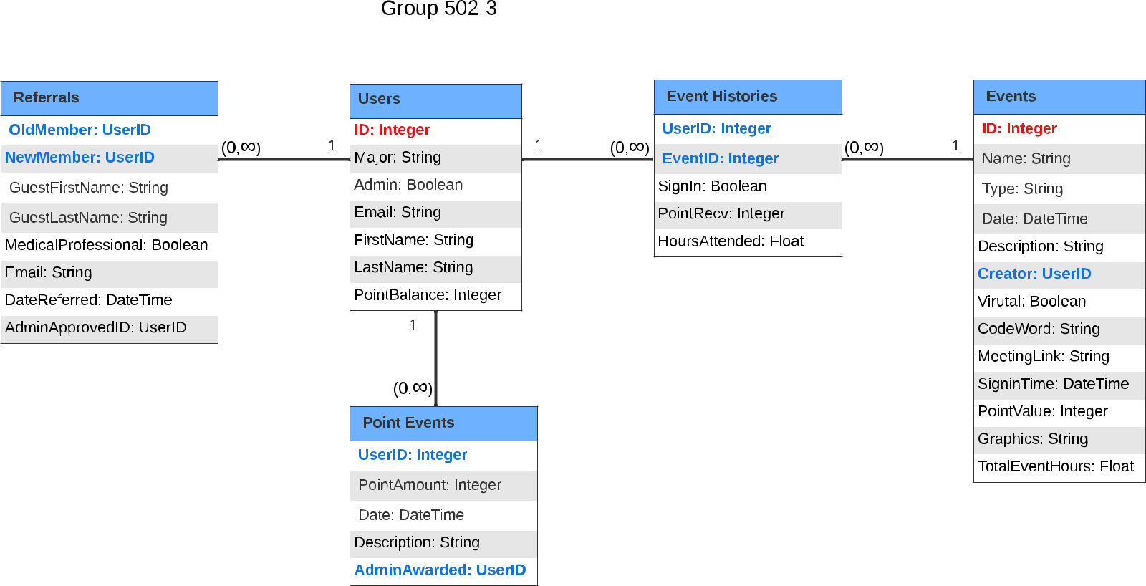

*Referrals*

*OldMember: UserID*

*NewMember: UserID*

GuestFirstName: String

GuestLastName: String

MedicalProfessional: Boolean

Email: String

DateReferred: DateTime

AdminApprovedID: UserID

(0,? ) 1

*Users*

*ID: Integer*

Major: String

Admin: Boolean

Email: String

FirstName: String

LastName: String

PointBalance: Integer

1

1. (0,? )

*Event Histories*

*UserID: Integer*

*EventID: Integer*

SignIn: Boolean

PointRecv: Integer

HoursAttended: Float

(0,? ) 1

*Events*

*ID: Integer*

Name: String

Type: String

Date: DateTime

Description: String

*Creator: UserID*

Virutal: Boolean

CodeWord: String

MeetingLink: String

(0,? )

*Point Events*

*UserID: Integer*

PointAmount: Integer

Date: DateTime

Description: String

*AdminAwarded: UserID*

SigninTime: DateTime

PointValue: Integer

Graphics: String

TotalEventHours: Float